Thursday
November 10, 2016

A part of the:
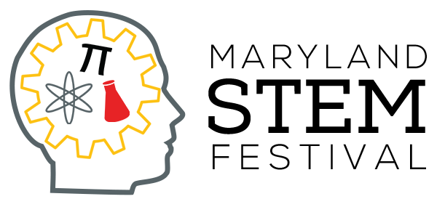

With thanks to our sponsors:

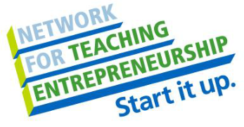

OVERVIEW
Hackers have gained control of Patterson High School and a variety of other places and systems critical to Baltimore’s and our nation’s security. Your team is tasked with solving the following six challenges to return our school, city, state, and nation back to safety.
If you are posting about this event on social media, please use the hashtag #STEM2016 Optional additional tags: #EngineerWithNoFear #ComputerTechPHS #HackTheFuture #STEMGirlsRule #AppThis #Coding #NFTE #PathwaysTo21stCenturySuccess

THE RULES

A. The LASER HEIST!

Hackers have helped thieves break into the Baltimore Museum of Art. Your task is to design an unhackable laser security system that will have lasers bouncing off mirrors to safeguard the artworks therein. Use your knowledge of geometry and your engineering skills to design and build a floorplan system of up to five mirrors that allow the laser to hit its target.

Teams will be given:
Mirrors (5) String, 72” Masking Tape, 36”
Protractor Ruler Styrofoam mounting board
NOTE: Your team does not need to use all the mirrors, but will receive more points the more mirrors you use, if the target is successfully hit with the laser.

At the testing station, teams will place their board into the testing apparatus, as guided by the judge. The testing apparatus will include a laser pointer mounted at a fixed position and a target area marked with point values.

Scoring – Teams will be given three official judged trials, with a chance to re-arrange the board in between. No practice trials are allowed on the official testing apparatus. Raw score will be determined as target value hit by the laser, times number of mirrors. The highest two scores of the three trials will be recorded. Scores will then be scaled so that the first place team receives 200 points, second place 190, etc.

B. HACK THIS SHIP!

Hackers have managed to take over the U.S.S. Patterson, bouncing their signals off satellites and slipping malware onto the ship’s “smart” computer controls. The ship is sinking and you have been called in to rescue the passengers (marbles). How many can you save without your own boat sinking?

The goal of this event is to float the maximum number of marbles on a 12 inch x 12 inch piece of aluminum foil. Each team will be allowed:
- two (2) pieces of aluminum foil, one for a practice and the second for the competition,
- two (2) large paper clips, and
- one (1) sheet of paper to plan out designs and calculate volumes

The practice piece must be turned in to the judges before the official piece may be obtained. You do not have to use the second piece of foil, but one is available if the team chooses to use it. The final design must float with the marbles for ten seconds. When you wish to have your rescue boat timed, just call for the judge. Once your device has been timed, you may not add more marbles. If your boat sinks while being timed and there is time left, you may not add more marbles to the device, but you may remove some to refloat it.

Scoring – The team that floats the maximum number of marbles will receive a score of 160 points, second place 150 points, etc. Forty (40) additional points will go to each team that correctly calculates the volume of their ship, showing all work.

C. H4CK TH1S 3GG!

Hackers have gained control of your airplane, steering it into a tornado. The plane gets flung sideways, with the controls no longer responding. To make matters worse, you test your newly-upgraded “smart” parachute and it doesn’t work. You and your best friend must figure out a way to make a protective drop container, using only the supplies at hand, before the plane crashes into the ground. The goal of this event is to design and build the least massive device to safely transport two eggs (you and your best friend) through a 4 meter drop and have it land safely without breaking. Only use the materials listed below, or your team will be disqualified.

8½”x14” Printer Paper (10) Balloon (1) Straws (10)
Rubber Bands (5) Masking Tape (36”) Cotton Balls (10)

Scoring – The least massive device for which both eggs remain undamaged and uncracked will receive a score of 200 points, the next least massive 195, etc. The least massive device for which only one eggs remains uncracked will receive a score of 100 points, the next least massive 95, etc.

D. The TOWER OF DOOM!

After all of the attacks above, which you have successfully defended against the hackers, your team decides to go on the offensive. You learn that the hackers are congregated in a downtown Baltimore skyscraper, on the top floor, and you discover a curious vulnerability: you can access their Wi-Fi and install a Trojan horse onto their system IF you are at the same height off the ground as they are, within a 2-block radius. So you decide to build your own skyscraper nearby, with the goal of hacking the hackers and gaining control of their network.

The goal of this event is to construct a tower to hold a tennis ball at its top. The tower must be free standing and self-supporting. The tennis ball must stay on top of the tower for at least 20 seconds without the tower falling over. Each team will be given the following materials to construct their towers:

Stirrer Straws (20) Craft Sticks (10) Gumdrops (40)
Construction Paper (5) 8½”x14” Printer Paper (10) Markers

Scoring – Towers that do not support the tennis ball will receive no points (0). The team with the tallest tower that supports the tennis ball will receive 160 points, second tallest 150, etc. Forty (40) points will be given for creativity, as judges on the accompanying rubric.

E. HACK THIS Pi!

Your team has cracked the hackers’ Wi-Fi password, and you learn that they are running their malware based off of a Python script. You need to quickly assemble a computer and write some Python code that will deactivate their software and save the city!

The goal of this activity is to learn some simple coding in Python, using the Raspberry Pi computers. You will begin by assembling your computer, opening Python 3, and writing a computer program that creates an interesting visual/artistic design using the Turtle Library in Python. You will be given:

Raspberry Pi Computer SD Card Keyboard Guide Sheets
Monitor HDMI to DVI Cable Mouse Rubric

You have 25 minutes to code. At the twenty-five minute mark, you must present your program and its visual output to the judges. As clean-up, you must delete your program and disassemble the Raspberry Pi computer into its component parts.

Scoring – Based on the attached rubric for program sophistication and creative expression. Your raw scale on the rubric will be scaled so that the first place team receives 200 points, second place 190, etc.

F. ENTREPRENEURIAL MATH!

You have defeated the hackers!! Unfortunately, in their wake they have destroyed large swaths of Baltimore’s infrastructure and shuttered many businesses. As the city begins to rebuild, we need your team to become entrepreneurs to sell needed products and services. This event will test your understanding of business math.

You will be given:

Business Math Questions Scratch Paper Answer Sheet
Pencils

Scoring – Each question is worth one point (raw score). The team with the highest raw score will have their score scaled to 200, second place 190, etc. Teams not earning any raw points on this activity will not have their score scaled.

